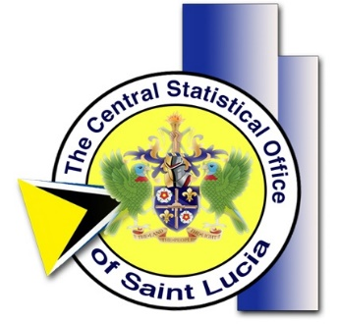

Background
The World Bank is providing support to countries to help mitigate the spread and impact of the new coronavirus disease (COVID-19). One area of support is for data collection to inform evidence-based policies that may help mitigate the effects of this disease.
An urgent need to monitor the rapidly changing impact of the COVID-19 and policy interventions has been identified. An adaptive system to track a range of indicators under the current evolving situation is needed. With a focus on the household’s behaviour responses, the system passes information from households to project teams and policymakers for their coverage and effectiveness. This timely information is crucial in establishing a fast response mechanism and taking actions to defeat the crisis.

The COVID-19 High Frequency Phone Survey (HFPS)
The Central Statistical Office supported by the World Bank is currently implementing the Saint Lucia COVID-19 High Frequency Phone Survey (HFPS).
The objective of the Saint Lucia National COVID-19 High Frequency Phone Survey (HFPS) is to monitor the socio-economic effects of this evolving COVID-19 pandemic in real time. These data will contribute to filling critical gaps in information that could be used by the Saint Lucia government and stakeholders to help design policies to mitigate the negative impacts on its population.
The project will run from May through June 2020, with the first round being in May and the follow up round in June.

